**Chapter-1**

**(Crop Production and Management)**

* **Notes -**
* **Till 10,000 BCE People were nomadic.**
* **Nomadic people eat raw food but later in time they cultivate land and produce rice wheat and other food crops. Thus, “Agriculture” word was born.**
* **When plants of the same kid are cultivated on a large scale is called Crop.**

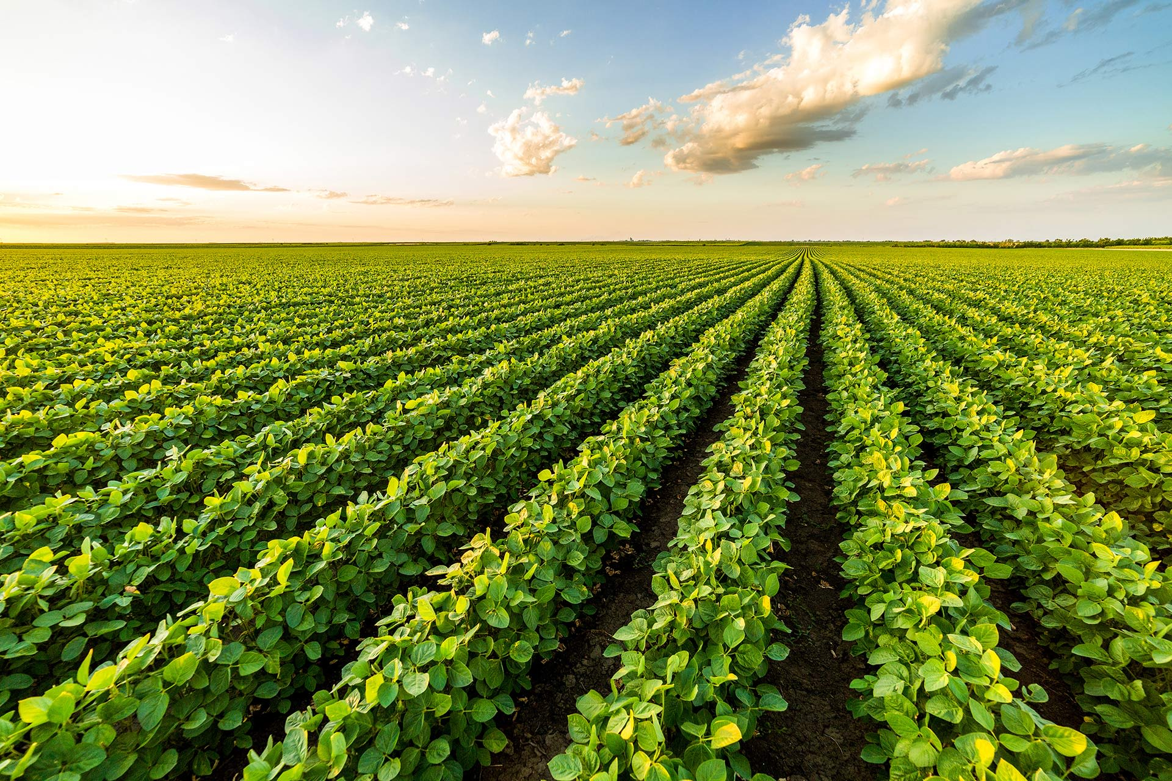

* **Kharif Crops – “Rainy season”, “June to September”, “paddy, maize Soyabean”.**
* **Rabi Crops - “Winter season”, “October to March”, “Wheat, pea, gram, linseed”.**
* **Pulses and vegetables are grown in Summer Season.**
* **Cultivation of Crops involves several activities under taken by farmers over a period of time is called Agricultural activities.**
* **Agriculture practices-**
  + **Preparation of Soil**
  + **Sowing**
  + **Adding manure and fertilizers**
  + **Irrigation**
  + **Protecting from weeds**
  + **Harvesting**
  + **Storage**
* **Preparation of soil First step- Loosening the soil by a instruments called “plough”. Loosening allows the roots to penetrate deep into the soil. So, the roots can breath easily.**

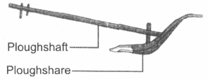

* **Loosening of soil helps in the growth of earthworms and microbes present in the soil.**
* **Loosening also allows the rich-nutrients Which is deep down in the soil comes at the top layer and plants can use it for their growth.**
* **The process of loosening the soil is called tilling or we can say ploughing both are correct options.**
* **This is done by using a plough or a Hoe.**
* **Hoe is used to remove weeds from field.**

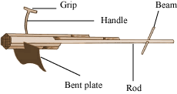

* **But Nowadays ploughing is done by tractor driven Cultivator the use of cultivator saves time and labour.**

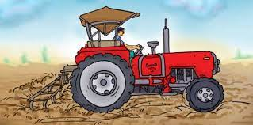

* **Sowing is the process of putting seeds under the loosened soil.**
* **There is a traditional tool used for sowing Seeds. That is a shaped like a funnel seeds are filled into the funnel it drilled the seeds at (approx) same space and depth.**

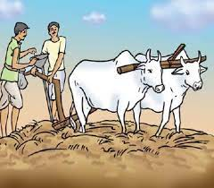

* **Nowadays there is a advance instrument called “Seed drill” for sowing. Seed drill drills the seeds at perfect and equal spaces and depth it save time and efforts.**

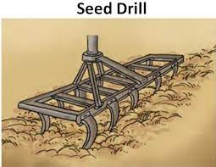

* **Substances which are added to the soil in the form of nutrients for the healthy growth of plants are called manure and fertilizers.**
* **Farmers have to add manure to the soil because continuous Cultivation of crops makes the soil poor in the nutrients This process is called “Manuring”.**
* **Improper or insufficient manuring result weak plants.**
* **Manure is a organic substance obtained from the decomposition of plants and animals wastes.**
* **Advantages of manure –** 
  + **It enhances the water holding capacity of the soil.**
  + **It makes the soil porous due to which exchange of gases becomes easy.**
  + **It increases the number of friendly microbes/microorganisms.**
  + **It imporves the texture of the soil.**
* **Some Disadvantages-** 
  + **Manure is relatively less rich in plant nutrients.**
  + **It Takes relatively more time for growth of the plant Than fertilizers.**
* **Fertilizers are Chemicals which are rich in a particular nutrient.**
* **Examples of fertilizers are – urea ammonium sulphate, super phosphate, potash NPK(Nitrogen, phosphorus, potassium).**
* **Advantage of fertilizers-** 
  + **Fertilisers has helped farmer to get better yield of crops such as wheat, paddy and maize.**
  + **Fertilisers are very rich in plant nutrients like nitrogen, phosphorus and potassium.**
* **Some disadvantages of fertilizers are –** 
  + **Fertilisers has made the soil less fertile**
  + **Fertilisers have also become a source of water pollution.**
* **Difference between Fertilisers and Manure-**
* 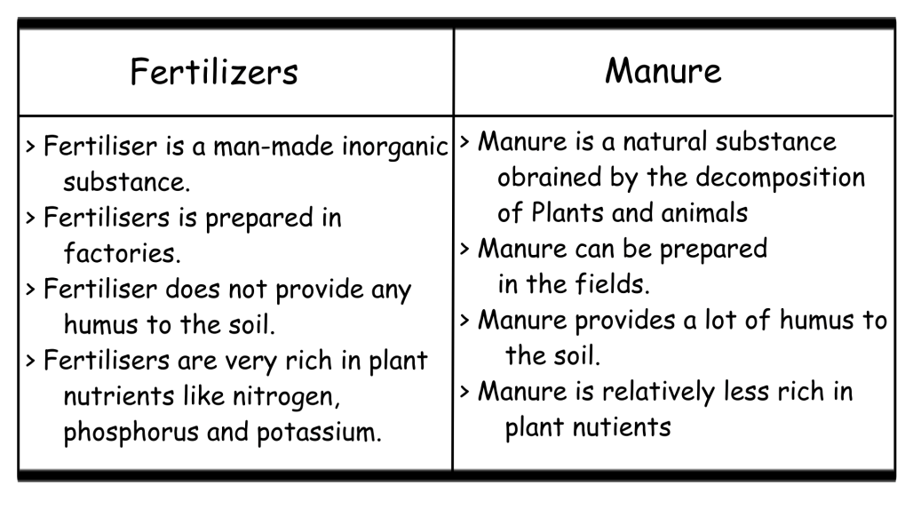
* **The process in which we rotate crops from the fields by different crops at regular intervals for the nutrients which are deep down in the soil comes at the top layer and different plants can use it for their growth is called “Crop rotation”.**
* **A bacteria Which Fix Atmospheric nitrogen is “Rhizobium”.**
* **Plants contain nearly 90% water.**
* **The supply of water to crops at regular intervals is called “Irrigation”.**
* **Some sources of irrigation are- Wells, Tubewells, ponds, lakes, rivers, dams and canals.**
* **Cattle or human labour is used in these methods. So these methods are cheaper but less efficient. The various traditional ways are:**
  + **Moat(Pulley-System).**

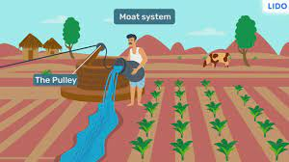

* + **Chain pump.**

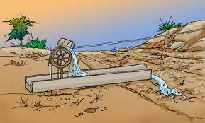

* + **Dhekli**

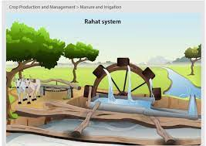

* + **Rahat(Lever-System)** 
    - 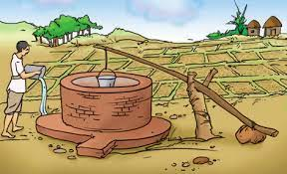
* **Modern methods of irrigation helps to use water economically. The main methods used are as follows:**
* **Sprinkler System: In this system perpendicular pipes having rotating nozzles on top, are joined to the main pipeline at regular intervals when water is allowed to flow through the main pipe under pressure with the help of a pump it escapes from the rotating nozzles .It gets sprinkled on the crop. This system is usually used in gardens, parks etc.**

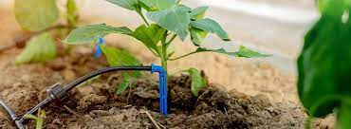

* **Drip System: In This system, The water falls drop by drop directly near the roots. So it is called drip system it is the best technique for watering fruit plants, gardens and trees this system is used when there is less availability of water.**
* 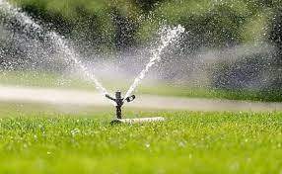
* **In the field many other unwanted plants grow naturally along the crop. These unwanted plants are called weeds.**
* **The removal of weeds is called weeding.**
* **Weeding is necessary because Weeds complete with the main crop for water, nutrients, space and light. And it results in improper growth of the crop and it will damage the crop.**
* **The best time to remove weeds is before they produce flowers and seeds.**
* **The manual removal includes physical removal of weeds by cutting them close to the ground from time to time. This is done With the help of a instrument called “Khurpi”.**

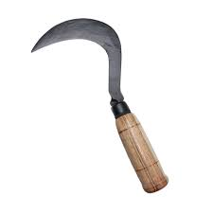

* **Weeds can also controlled by using certain chemicals, called Weedicides.**
* **Diagram of Weedicides:**
  + 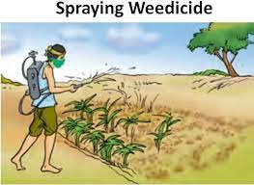
* **These are sprayed in the fields to kill the weeds . they do not damage the crops.**
* **Weedicides are diluted with water to the extent required and sprayed in the fields with a sprayer.**
* **Harvesting of a crop is an important task. The cutting of crop after it is fully grown is called harvesting.**
* **It usually takes 3 to 4 months for a cereal crop to mature. Harvesting is done by in our country is either done by sickle or by a machine.**
* **After harvesting the crop the grain seeds need to be separated from the chaff. This process is called threshing.**
* **Threshing is done by a machine called ‘Combine’.**

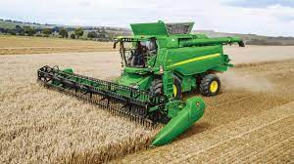

* **Farmers with small holding of land do separation of grain and chaff by Winnowing.**
  + **-**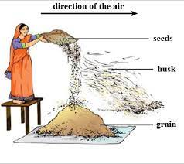
* **Some harvesting festivals are Holi, diwali, Nabanya and bihu.**
* **After harvesting Grains are to be kept for longer time, they should be safe from moisture, insects, rats and microorganisms If freshly harvested grains(seeds) are stored without drying they may get spilt or attacked by organisms, making them unfit for use or for germination. This is called “Storage”.**
* **Farmers store grains in jute bags or metallic bins. However large scale storage of grains is done in silos and granaries to protect them from pests like rats and insects.**
* **Dried neem leaves are used for storing large quantities of grains in big godowns, specific chemical treatments are require to protect them from pests and microorganisms**
* **When animals reared at home or in farms, have to be provided with proper food, shelter and care, When this is done on a large scale. It Is called animal husbandry.**

